Appendix 1

Patient Presentation

Patient:

23-year-old male professional footballer of British Caribbean descent.

Significant history of intermittent LBP approximately 5 years

Pain:

Dull ache centrally over L3 to L5 L > R
Activity dependent: reports “tightening sensation of lumbar extensors”

Severity = Low,

NPRS:
8 /10 @ worst - high intensity running.

0/10 @ best - rest
Nil radicular pain

Nil neurological deficit

Red Flags:

No P&N / numbness / loss of sensation

No night pain
No Bladder & Bowel complaints,

NO sudden weight loss.

Imaging:

MRI August 2016 – NAD (See Appendix 2: MRI report)

PMH:

(See Appendix 3, chronological data injury sheet)

DH:

Vitamin D supplementation

24hr pattern:

- Morning stiffness & discomfort on waking which eases with movement.

- Onset of pain becomes worse with activity and continues to get worse during the session until activity has ceased.

- Increase in intensity causes increase in pain.

- Gradually improves with rest,

- Sustained postures / positions for periods longer than 30 mins e.g sitting & sleeping aggravate condition

Appendix 1 (cont.)

Body Chart

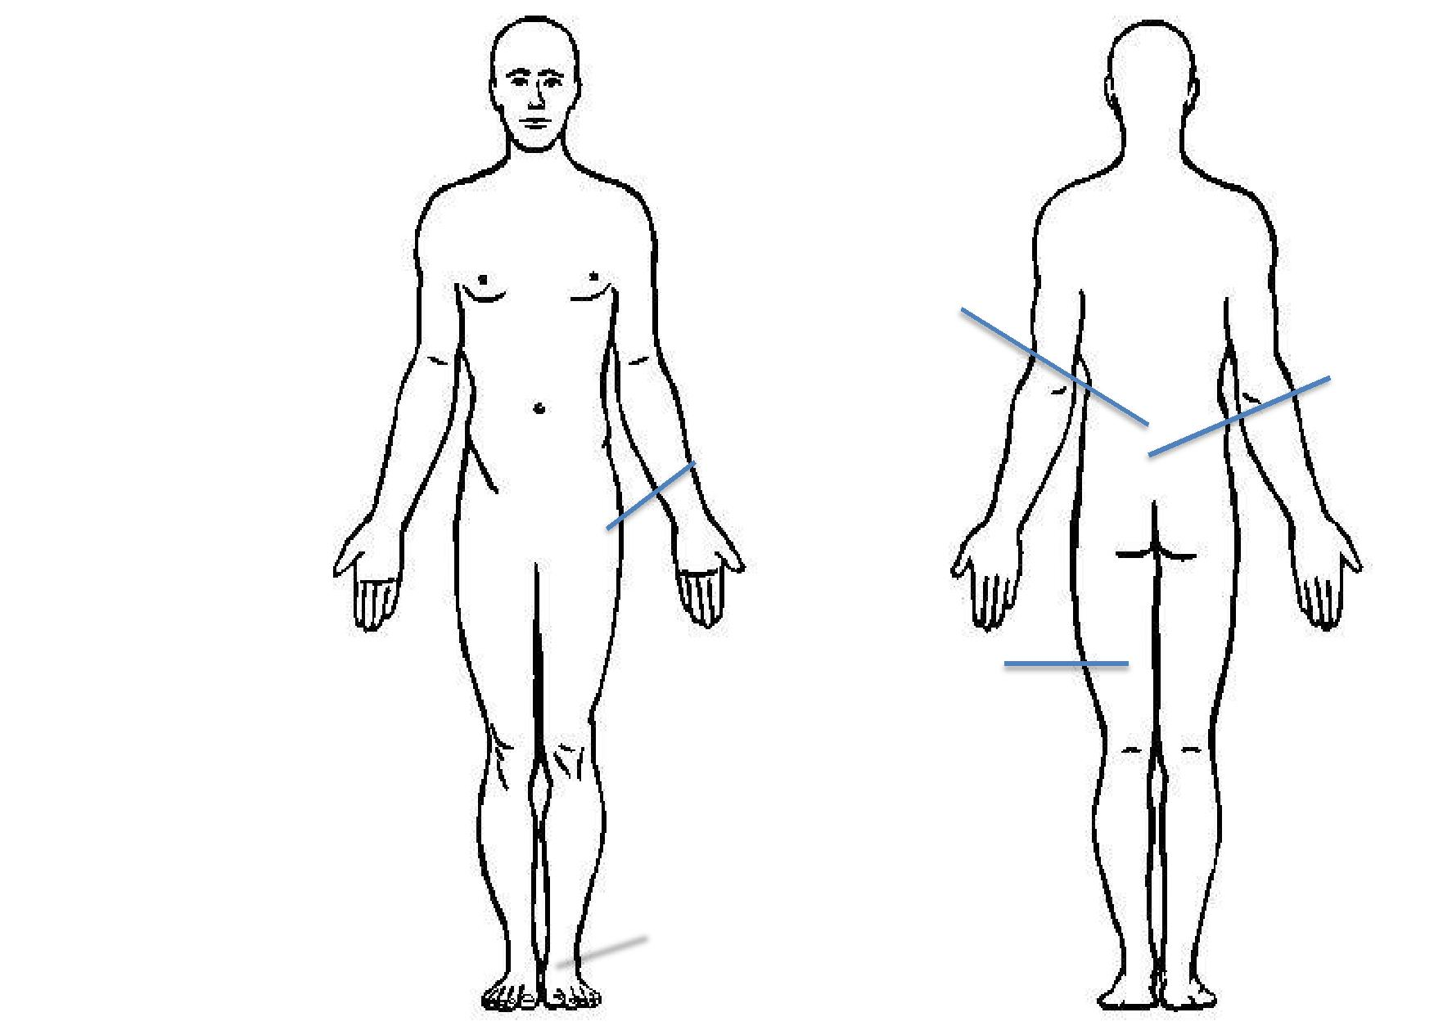

Aggravating factors:

- High intensity running

- Gym exercise contracting the lumbar muscles (eg. Bridging, hyperext)

- Sustained static positions

Easing Factors:

- Rest from activity

- Stretching programme

Intermittent Non
Specific Low Back Pain

of Lumbar extensors and
paraspinal muscles

Anterior pelvic tilt

and tight hip flexors

Significant History of
non-contact hamstring

strains

History of medial

malleolous

stress fracture

Appendix 2

Objective Assessment

Observation:

- Protracted shoulders bilateral.

- Stands in anterior pelvic tilt with increased Lumbar Lordosis.

- Lumbar scoliosis concave left.
- Normal gait

Neurodynamic Testing:

SLR – NAD
Slump - NAD

Muscle Length Test:

Quadriceps length Prone Knee Bend: R=L

Thomas Test –

Left - NAD
Right – Hip abduction

Hypermobility:

Beighton’s Score: 1 (Lsp)

Hip Assessment:

ROM – Full range Strength – 5/5 Quadrant - NAD

Anthropometrics:
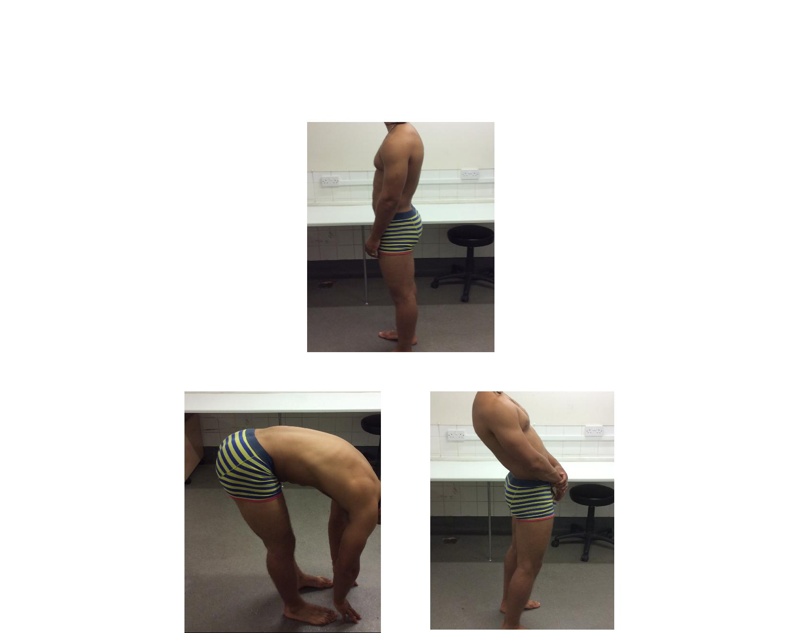

Age – 23 Height – 162cm Weight – 85kg

Range of Movement (ROM):

Full active ROM
- Flexion

- Extension (pain end of range)
- Left side flexion (pain ipsilateral)

- Right side flexion (pain contralateral)

Palpation:

High tone Erector Spinae & Lumbar paraspinals TOP+ L2 – L5

Provocation Testing:

Sacroiliac Joint: Distraction – NAD Thigh Thrust – NAD FABER’s – NAD Compressions - NAD Gaenslan’s – NAD

Pubic Symphysis:
PSST - NAD

Analysis:

The player presents with a significant anterior pelvic tilt and hyperlordosis of the lumbar spine, possibly increasing abnormal load through Lsp facet joints, which is aggravated specifically when running. In the absence of a pathoanatomical disruption, the presentation of symptoms correspond with a neurophysiological model of chronic low back pain corresponding with complex biochemical & neuromodulation changes at a peripheral, as well as at spinal cord and cortical level [3].

Appendix 3

Multi-modal Management Plan:

Education

Cognitive
Behavioural
Techniques

Mindfullness

Posture Re- |  | Multi-Modal
 |  | Management
Education
 |  | Plan

Acupuncture

Stretching /
Self
Mobilisations

Functional
Core

Manual
Therapy

Running
Mechanic
Drills

Appendix 4

MRI Report
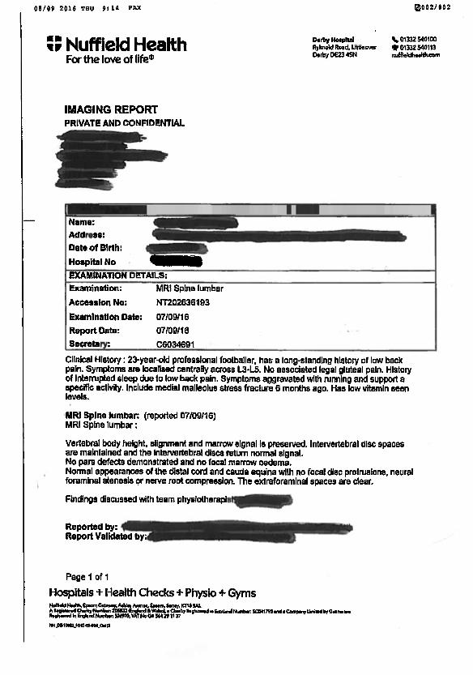

Appendix 5

Chronological Injury Data

Injury | Limb | Date | Mechanism of injury | Rehabilitation | Days to RTP
 |  |  |  |  | 6
Adductor longus strain | Right | 15/07/14 | Non-contact over stretch for the ball | Posture Re-education
 |  |  |  | S&C gym / pitch rehab
 |  |  |  |  | 22
Hamstring strain | Left | 20/03/15 | Non contact. Sprinting for ball and felt | Compression
 |  |  | hamstring discomfort | Hydrotherapy
 |  |  |  | Manual therapy - Lsp, hamstring &
 |  |  |  | gluts
 |  |  |  | Dry needling to piriformis
 |  |  |  | S&C
 |  |  |  | Pitch based rehab
 |  |  |  |  | 10
Rectus Femoris Strain | Right | 13/07/15 | Non contact, gradual onset of | Rest / offload period
 |  |  | tightness. Worsening picture over | S&C
 |  |  | proceeding 24hrs | Return to Running
 |  |  |  |  | 23
Hamstring Strain | Left | 14/08/15 | Non contact. Sprinting for ball and felt | Compression
 |  |  | hamstring discomfort | Hydrotherapy
 |  |  |  | Manual therapy – Lsp, hamstring &
 |  |  |  | gluts
 |  |  |  | Dry needling to piriformis
 |  |  |  | S&C
 |  |  |  | Pitch based rehab
 |  |  |  |  | 168 (ongoing)
Medial malleolous Stress | Left | 02/04/16 | Gradual onset of symptoms following | NWB in aircast boot
Fracture |  |  | significant increase in training load | Gait Re-Education
 |  |  |  | S&C / pitch based running

Appendix 6

Diagrams of Acupuncture Sites

Urinary Bladder Meridian

BL23
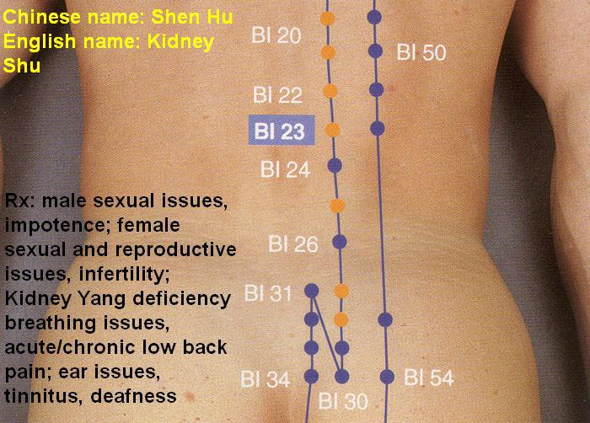

BL24
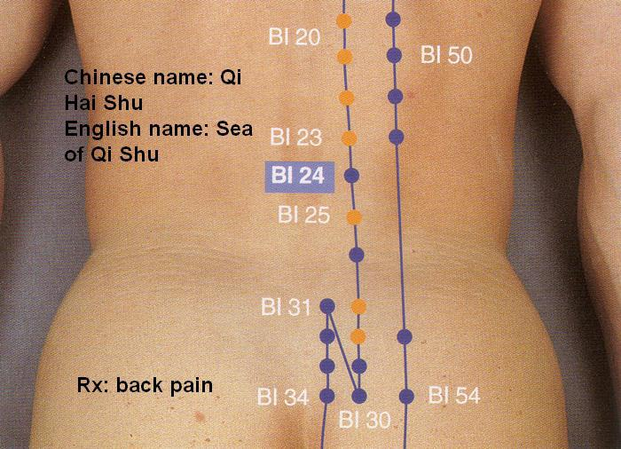

Appendix 6 (cont.)

Diagrams of Acupuncture Sites

BL25
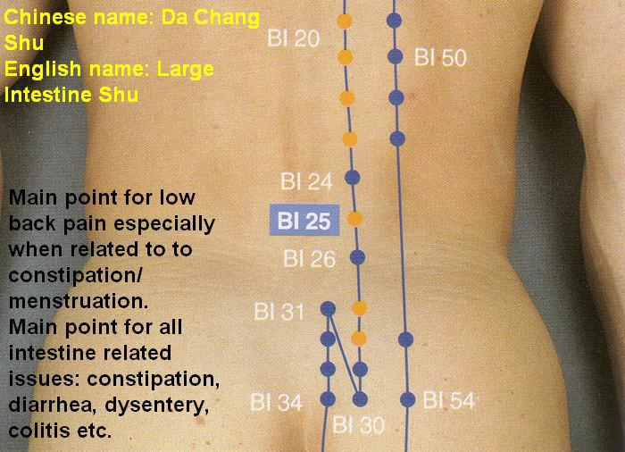

BL56
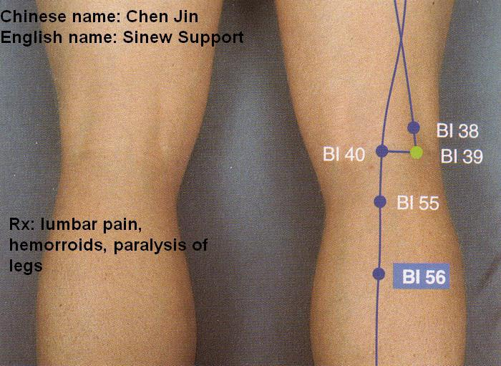

BL62
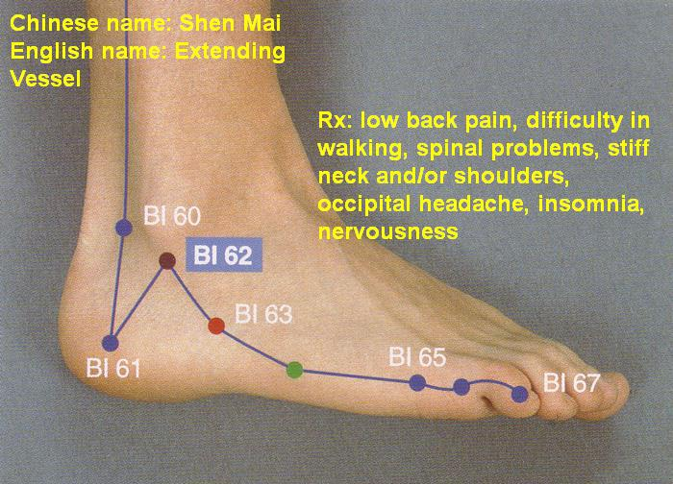

Appendix 6 (cont.)

Diagrams of Acupuncture Sites

Gall Bladder Meridian

GB30
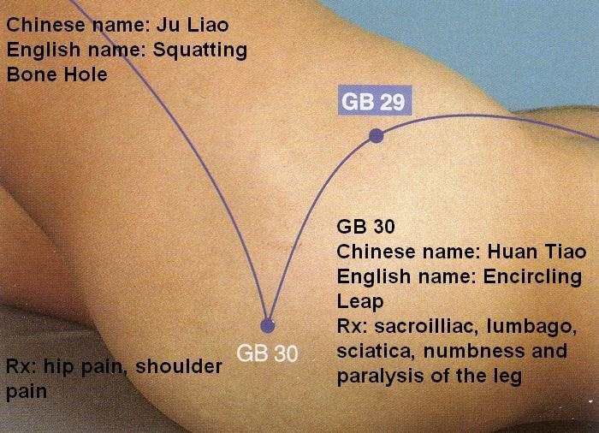

Small Intestine Meridian

SI3
