Annex 1. Nutrient Mixture F-12 Ham Formulation
- Nutrient Mixture F12 Ham
- Nutrient Mixture F12 Ham HEPE Modification
Nutrient Mixture F-12 Ham
Component | N4888  [1x] g/L | N6658  [1x] g/L | N6760  g/L
Inorganic Salts
Calcium Chloride | 0.0333 | 0.0333 | 0.0333
Cupric Sulfate • 5H₂O | 0.0000025 | 0.0000025 | 0.0000025
Ferrous Sulfate • 7H₂O | 0.000834 | 0.000834 | 0.000834
Magnesium Chloride | 0.0576 | 0.0576 | 0.0576
Potassium Chloride | 0.224 | 0.224 | 0.224
Sodium Bicarbonate | 1.176 | 1.176 | —
Sodium Chloride | 7.599 | 7.599 | 7.599
Sodium Phosphate Dibasic (anhydrous) | 0.14204 | 0.14204 | 0.14204
Zinc Sulfate • 7H₂O | 0.000863 | 0.000863 | 0.000863
Amino Acids
L-Alanine | 0.009 | 0.009 | 0.009
L-Arginine • HCl | 0.211 | 0.211 | 0.211
L-Asparagine • H₂O | 0.01501 | 0.01501 | 0.01501
L-Aspartic Acid | 0.0133 | 0.0133 | 0.0133
L-Cysteine • HCl • H₂O | 0.035 | 0.035 | 0.035
L-Glutamic Acid | 0.0147 | 0.0147 | 0.0147
L-Glutamine | — | 0.146 | 0.146
Glycine | 0.00751 | 0.00751 | 0.00751
L-Histidine • 3HCl • H₂O | 0.02096 | 0.02096 | 0.02096
L-Isoleucine | 0.00394 | 0.00394 | 0.00394
L-Leucine | 0.0131 | 0.0131 | 0.0131
L-Lysine • HCl | 0.0365 | 0.0365 | 0.0365
L-Methionine | 0.00448 | 0.00448 | 0.00448
L-Phenylalanine | 0.00496 | 0.00496 | 0.00496
L-Proline | 0.0345 | 0.0345 | 0.345
L-Serine | 0.0105 | 0.0105 | 0.0105
L-Threonine | 0.0119 | 0.0119 | 0.0119
L-Tryptophan | 0.00204 | 0.00204 | 0.00204
L-Tyrosine • 2Na • 2H₂O | 0.00778 | 0.00778 | 0.00778
L-Valine | 0.0117 | 0.0117 | 0.0117
Vitamins
D-Biotin | 0.0000073 | 0.0000073 | 0.000073
Choline Chloride | 0.01396 | 0.01396 | 0.01396
Folic Acid | 0.00132 | 0.00132 | 0.00132
myo-Inositol | 0.018 | 0.018 | 0.018
Niacinamide | 0.000037 | 0.000037 | 0.000037
D-Pantothenic Acid (hemicalcium) | 0.00048 | 0.00048 | 0.00048
Pyridoxine • HCl | 0.000062 | 0.000062 | 0.000062
Riboflavin | 0.000038 | 0.000038 | 0.000038
Thiamine • HCl | 0.00034 | 0.00034 | 0.00034
Vitamin B₁₂ | 0.00136 | 0.00136 | 0.00136
Other
D-Glucose | 1.802 | 1.802 | 1.802
Hypoxanthine | 0.00408 | 0.00408 | 0.00408
Linoleic Acid | 0.000084 | 0.000084 | 0.000084
Phenol Red • Na | 0.0013 | 0.0013 | 0.0013
Putrescine • HCl | 0.000161 | 0.000161 | 0.000161
Pyruvic Acid • Na | 0.11 | 0.11 | 0.11
Thioctic Acid | 0.00021 | 0.00021 | 0.00021
Thymidine | 0.00073 | 0.00073 | 0.00073
Add
L-Glutamine | 0.146 | — | —
Sodium Bicarbonate | — | — | 1.176
See more at:
http://www.sigmaaldrich.com/life-science/cell-culture/learning-center/media-formulations/f-12-ham.html#sthash.OZHvwQfj.dpuf
Annex 2. Hcel®NaT (specification)
Producer: Holzbecher, spol. s r.o. barevna a bělidlo Zlíč, Czech Republic.
The dressing material is made of modified cellulose Hcel® NaT, sodium carboxymethyl cellulose by carboxymethylation of non-woven, the so called spun-laced textile material PurCotton® (Winner Medical, China). This structure and the selected degree of carboxymethylation (substitution) allows the material to stay strong when wet and minimises lateral wicking. Partially carboxymethylated cellulose dressing turns into a gel when wet and retains moisture in the wound. The dressing is easy to remove from the wound in one piece.

Product specifications:
(DS – degree of substitution)(14): 0.3
Contact pH (15): 6.7
Basic weight: 70 g/m²
Absorption capacity (16) 12 g/g (physiological solution)
The product is sterilised by radiation and made of high purity cellulose without any additional substances.

The degree of substitution shows how many basic cellulose units (glucopyranose units) are substituted by the functional group - CH₂COONa (in average). Determined according to the Czech Pharmacopoeia(14).
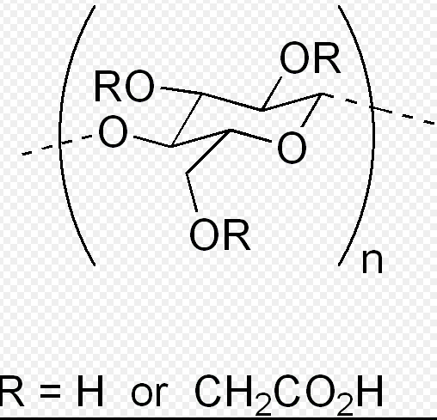

Carboxymethyl cellulose in wound management
Carboxymethyl cellulose is one of the first materials to be used in wet wound healing (so called hydrocolloid dressing (12)). Later, the company Convatec introduced the so called hydrocolloid fibres (Hydrofibre TM) in a product range called Aquacel (13). Hcel®NaT is another cellulose dressing that has been launched on the market recently.

